AWS CLOUD PROJECT
This project develops a serverless backend for Bynix Technology using AWS services to eliminate server management and simplify deployment. AWS Lambda handles on-demand code execution, while Amazon API Gateway manages secure API endpoints. Amazon DynamoDB provides a scalable NoSQL database for fast data access, and Amazon S3 stores static assets like images and web content. The architecture ensures high availability, automatic scaling, and cost efficiency for modern web and mobile applications.

Steps:
- Create an S3 bucket
- Create DynamoDB
- Lambda function
- API gateway

Create Dynamo DB:
- Open the AWS free server, Type the Dynamo DB in search bar. Click Dynamo DB.
- Type Bynix_table in table name.
- Type MessageID in Partition Key.
- Type SK in sort key(Optional).
- Click Create table.
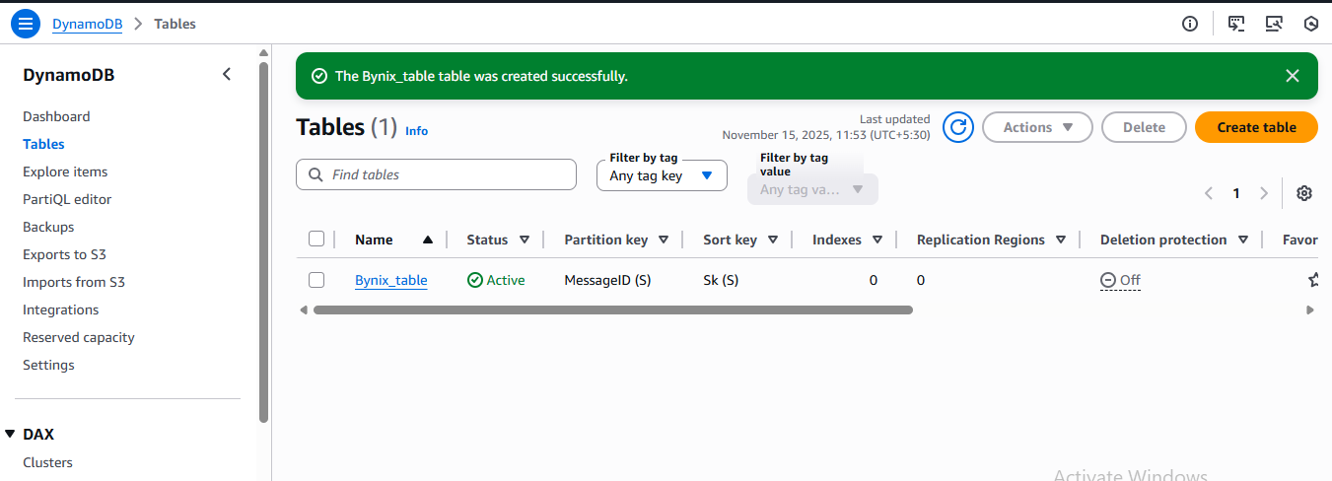

Create S3 bucket
- Type S3 bucket in search bar. Click S3 Bucket.
- Click Create Bucket.
- Type the name of bucket is bynix-backup
- Select the checkbox for Block all public Access.
- Choose Enable the bucket version
- Choose SSE-SE or SSE-KMS for Encryption Type.
- Select Enable the bucket key.
- Click Create Bucket button.
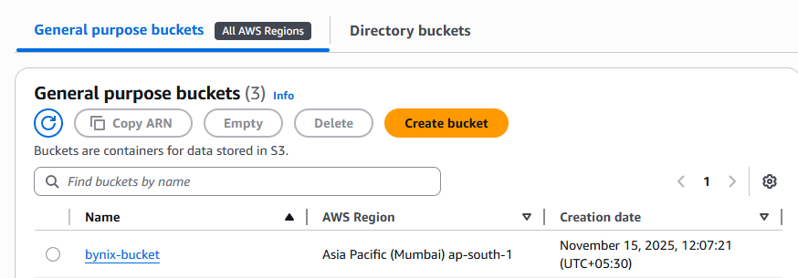
- Open the bynix-bucket and upload the index.html file and app.py for this bucket and click upload
- Then Go the properties menu and Click Edit in static website hosting menu.
- Select enable static website hosting.
- Select Host a static website in hosting type.
- Type Index.html in index document and then click save changes button

Create Lambada function
- Type the Lambda in search bar and click Lambda function.
- Now click create a function.
- Select Author from scratch from function
- Type bynix-function in function name.
- In Additional configuration Tab
  - Select Enable in Function URL.
  - Select Enable in VPC
  - Choose the default VPC and default security group.
  - Choose default ap-south-1a, ap-south-1b, ap-south-1c in subnet group.
- Click create function.
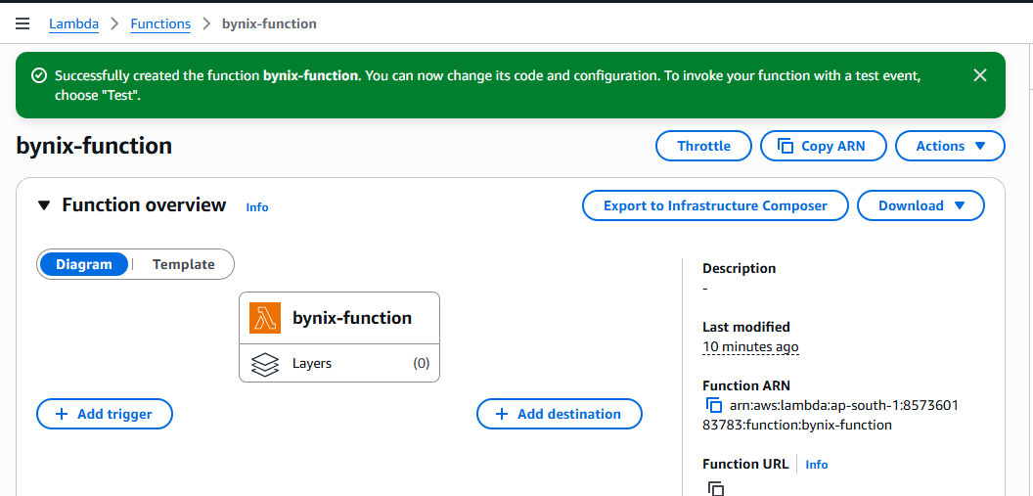
- Click the code menu-> click upload menu button-> click .zip files. Select youe project zip file and upload it.
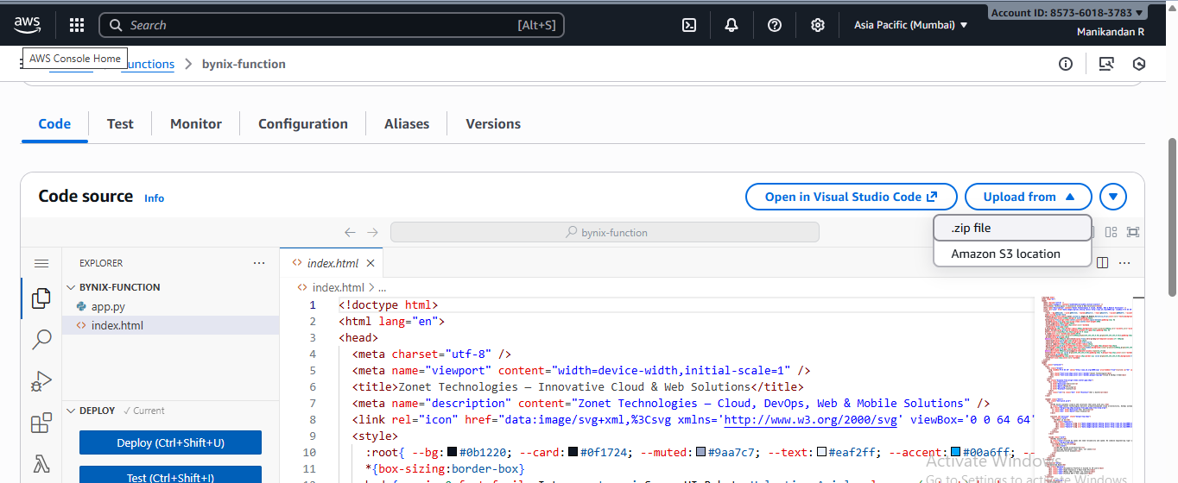
- Then go below to Runtime Settings tab -> click Edit button.
- Here lambda_function.lambda_handler and changed to app.lambda_handler or app.content in Handler field and click save button. Now click Deploy.
- Go to the Test tab, select API Gateway AWS Proxy in template. Now click Test Button.
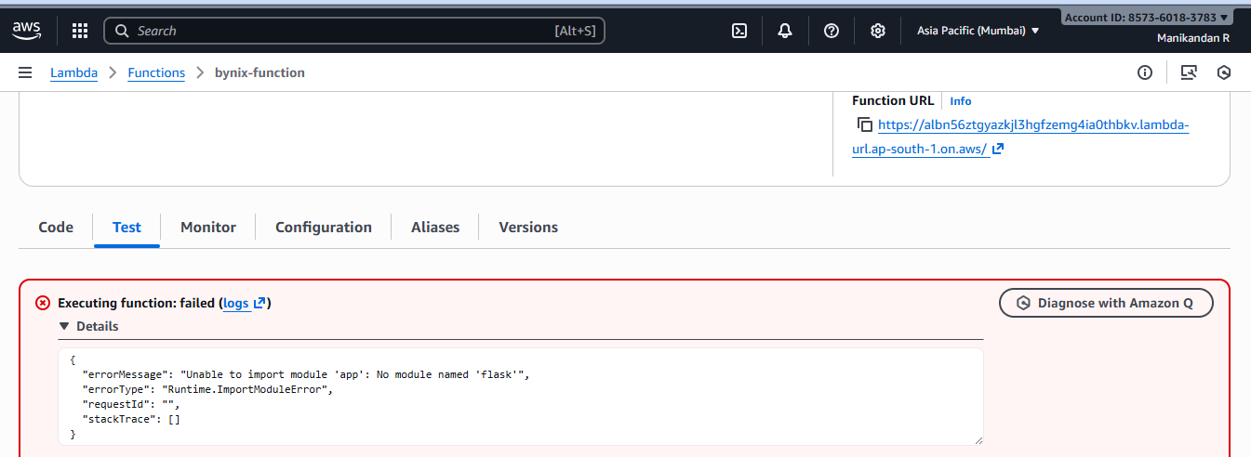
- Above the error showing. Here Library function is missing. Now we can add the Layer and import the library function
- Click Layer in left navigation menu. Select Layer->Click Create Layer.
- Type bynix-layer in the Name.
- Click Choose file button upload the python.zip file(Library files).
- Select x86_64 in compatible architecture.
- Select Python 3.13 in compatible runtime and click Save Button.
- Now go to the Lambada function. Select bynix-function, then Go to the Layer tab.
- Click Add a Layer button.
- Select the specify an ARN
- Copy the bynix-layer ARN and paste it the in specify an ARN and Click verify button. Now Compatible architecture and Compatible version is showing automatically. Click Add Button. Now click Deploy.
- Go to the Test tab, select API Gateway AWS Proxy in template. Now click Test Button.
- Type the API Gateway in search bar.
- Click Create an API button.
- Choose REST API and click build button.
- Create REST API page has opened.
- Choose NEW API in API Details.
- Type Bynix-API in API Name .
- Choose Regional in API endpoint .
- Choose TLS_1_0 in security Policy and then Click Create API button.
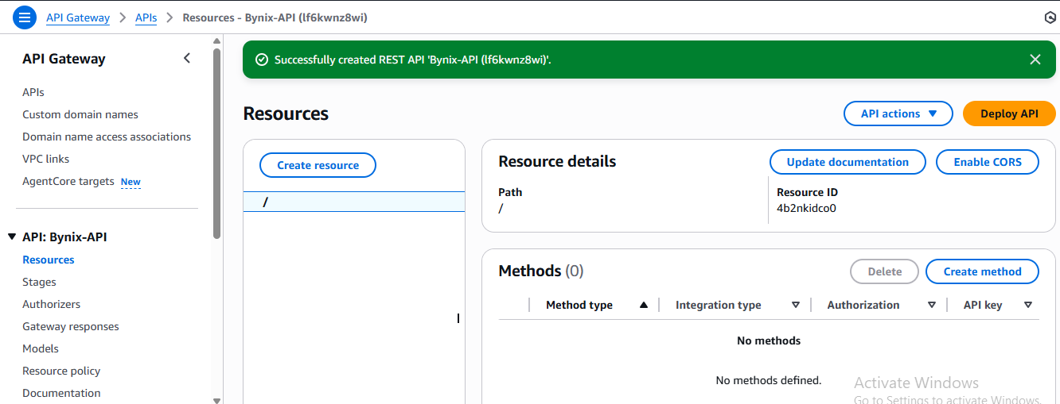
- Now Click Create method button.
- Now Method page is open. Choose ANY in method type.
- Choose Lambda function in integration type.
- Choose Enabled Lambda Proxy Integration.
- Choose your Zone and Lambda function(ARN link for Bynix_function)
- Click Create Method button.
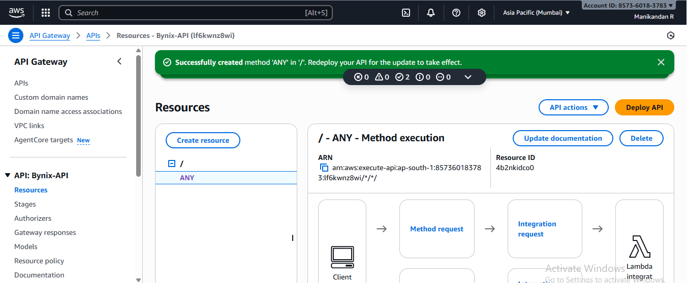
- Now Click Create Resource button.
- Now create Resource page is open. Choose Enabled Proxy Resource.
- Type {proxy+} in Resource Name and Click Create Resource button.
- Choose your Zone and Lambda function(ARN link for Bynix_function)

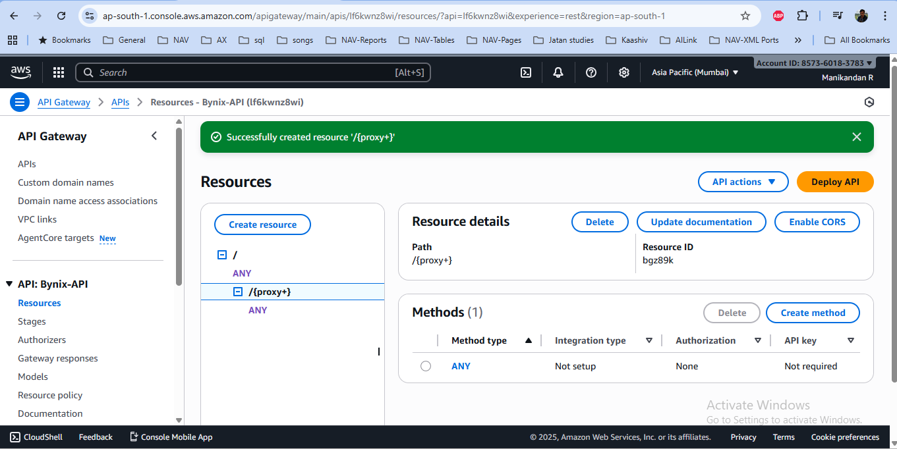
- First ”/” is whoever will able to come and second “/” Whoever will get the access anywhere.
- Now Choose second any and right side click Edit Integration.
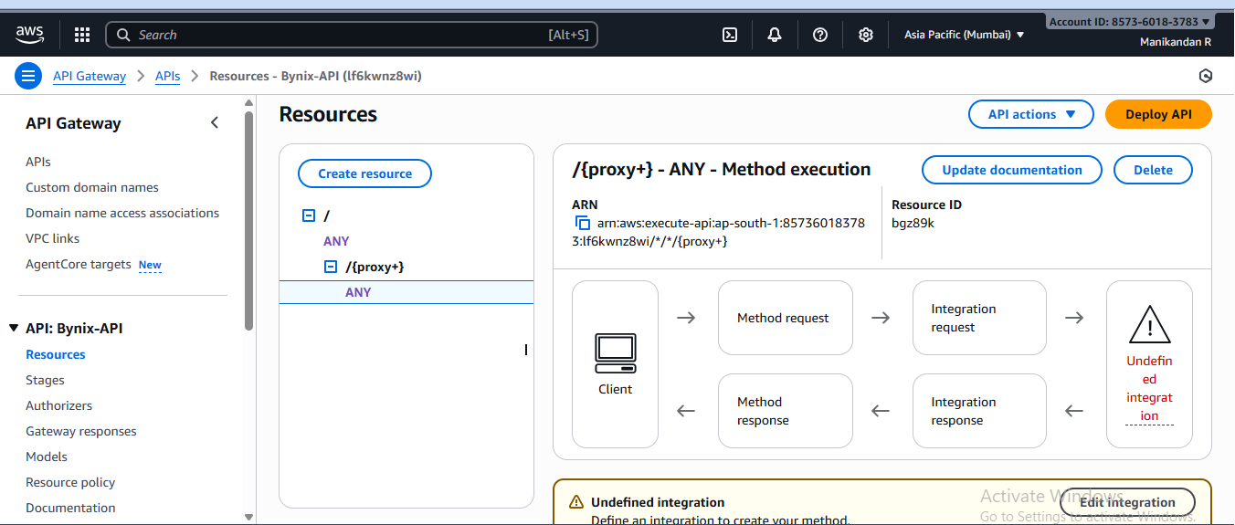
- Now Edit Integration request page will open.
- Choose Lambda function in integration type and Click Save Button
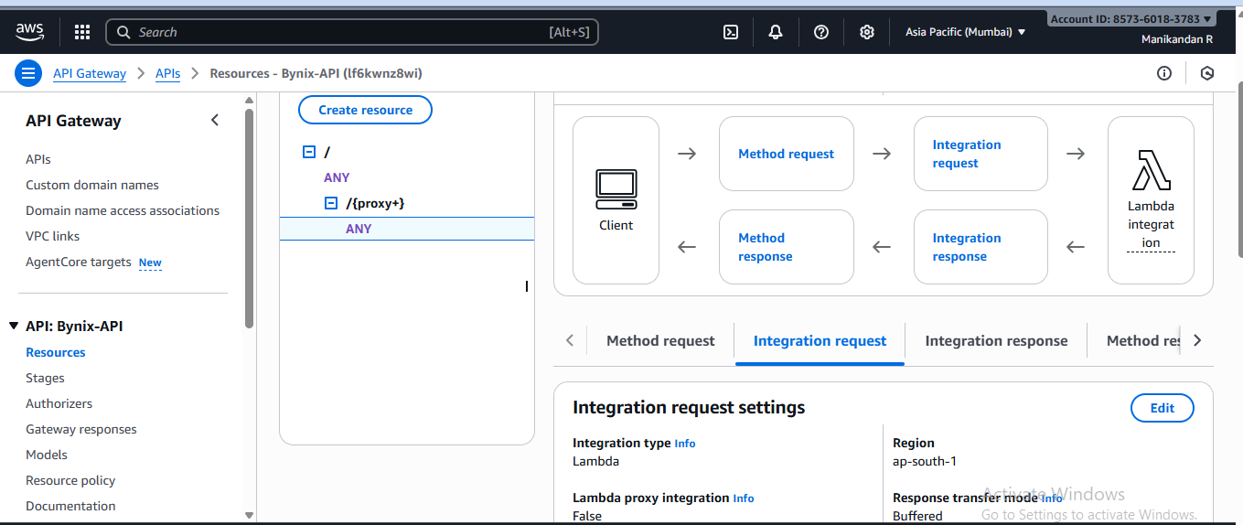
- Now Lambda integration added here. After click Deploy API Button.
- Now Deploy API dialogbox is open.
- Choose *New stage* in stage.
- Type dev or pro in stage name(dev means development, pro means production).
- Click Deploy button.
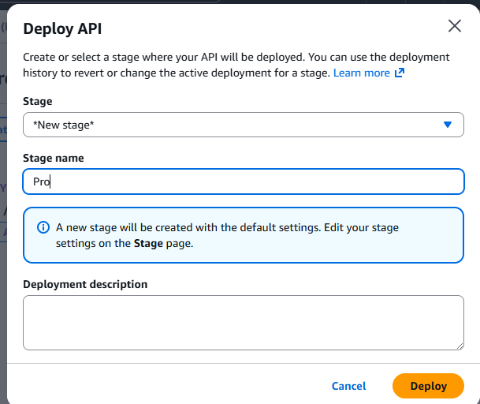

- Now Resource page will move automatically in stage page
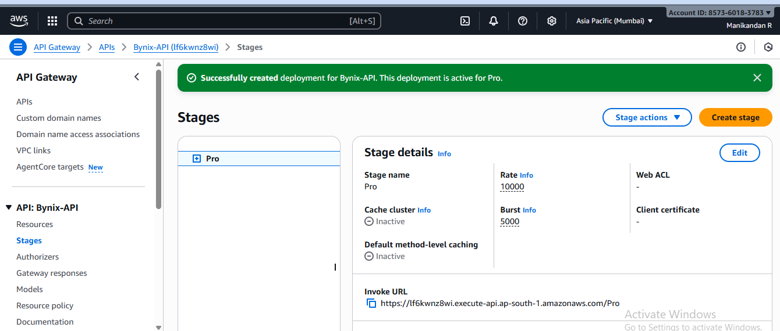

- Now Copy the invoke URL and paste the url in browser.
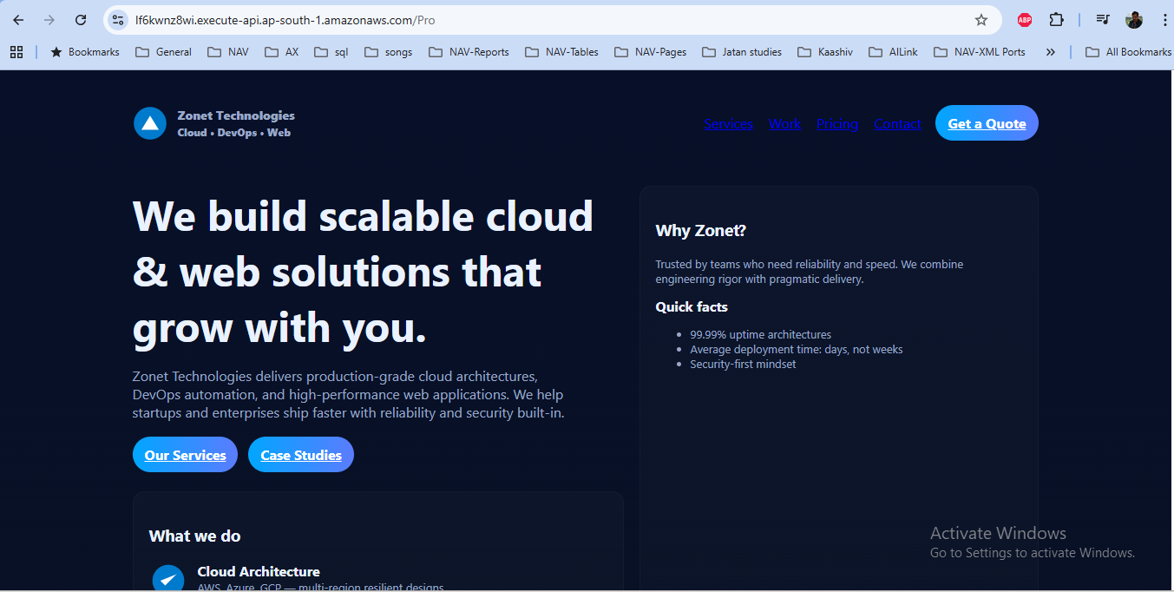

- Now go to the bynix function page API gateway added in function.
